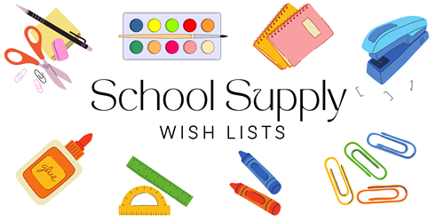

**5H GRADE – DUAL LANGUAGE ONLY**

**24/25**

3 COMPOSITION NOTEBOOKS (ANY COLORS)

2 12 or 24 PACK CRAYOLA COLORED PENCILS

3 30ct TICONDEROGA PENCILS – SHARPENED

1 PENCIL POUCH

1 PAIR OF STUDENT SCISSORS

1 CONTAINER LARGE ELMER GLUE STICKS

2 LANYARDS WITH ID HOLDER

**GIRLS ONLY:**

1 PACKAGE OF NOTEBOOK PAPER

1 BOTTLE OF ELMERS GLUE

**BOYS ONLY:**

1 REAM OF COPY PAPER

1 BOX OF KLEENEX TISSUES

**\*\*PLEASE NOTE – TEACHERS MAY HAVE OTHER ITEMS THEY WILL REQUEST AT THE OPEN HOUSE OR MEET & GREET\*\***